SIAG Questionnaire Results
May 2013

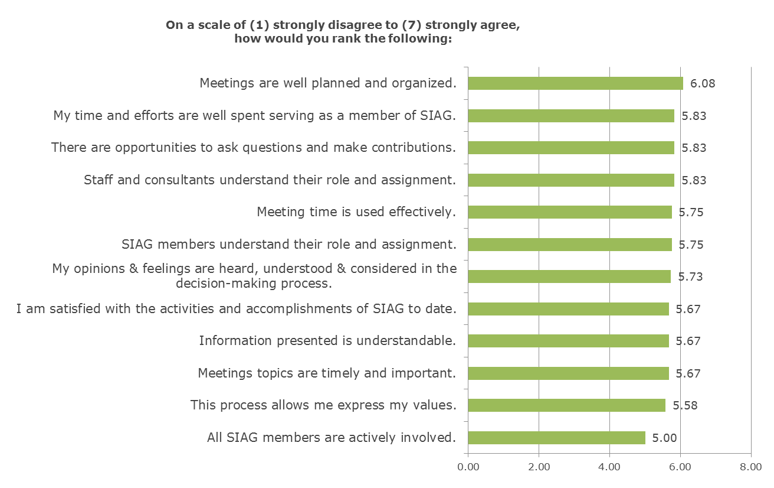

What suggestions can you offer for improving SIAG meetings or the master planning process?
- Send materials in advance.
- Speed up process.
- Challenge our assumptions/pre-conceived notions--look at the full range of options.
- Keep everyone on the same page as much as possible.

Which topic(s) you would like addressed by the SIAG at future meetings?
- Demand for sewer.
- Total tolerable system costs, how that will be financed, and impacts to sewer rates.
- Revenue sources.
- Conservation as a technology evaluated in optimization along with other technologies, like pipes, inline storage, alternative treatment, etc.
- Grey water reuse and what role it might play in controlling collections system costs, both with the current UGB and as our community grows in the future. Make a recommendation for the future.
- Mini-update about what the Council decided to do about the SE interceptor.
- Review the big picture of what we have left to do and how we're going to do it.
- Update on the designs for the immediate capacity solutions.
- Project costs / scope creep.

SIAG decision summary suggestions:
Meeting #9: Satellite Treatment Alternatives for Optimization (April 4, 2013)
- Include discussion of conservation as a technology that will be evaluated, how it will be dealt with (sensitivity analysis), and the need for rational basis for conservation scenarios and costs for comparison.
- Document decisions/recommendations to use sensitivity analyses to test how well the optimized solutions can deal with variations in densities (that might end up being part of the final response to the UGB remand) and/or to test how well the optimized solutions might deal with a larger population that would come with future growth and associated UGB expansion.

